Location sheet for Winter Pop Up / PlayCan inclusive outdoor play session
Whitecraig park, 29th December 2022, 12noon – 3pm
Where | Whitecraig Park, Whitecraig. Accessible via Whitecraig Crescent.
Parking | There is a small car park next to the Playpark close to where the activities will be running. It can sometimes be a bit muddy but there is a flat tarmac leading up to the car park where vehicles can stop if needed.
Public transport | Lothian Buses, East Coast Buses and Prentice Coaches run buses to Whitecraig. We recommend TravelineScotland for up-to-date information.
Toilets | There are no public toilets at the park.
Wheelchair access | The main surfaces are large grassy areas with wide paths that take you across the space. As well as the Playpark there is also a flat tarmac sports area.  Our activities will be located on and near the paths and sports area.
Seating and benches | There are some seating options in the park.  Our team will have a couple of folding chairs available.
Things to be aware of | Wrap up warm for the weather. We’ll have active games to keep warm and a tent for shelter. We also have spare jackets and gloves if you forget to bring yours or need an extra layer!  This is a spacious, green park which is mainly enclosed by hedges, walls and fences.  There are a few entrances into the park.  The space is open to members of the public, who may have dogs with them.  Whitecraig Playpark is a fairly ‘typical’ enclosed play area with wood chip surfaces, including equipment for climbing, tolder swings, a flying fox.
PlayCan resources | The team will bring a range of resources including ‘loose parts’ play kit, percussion, pots & pans, large tent, shelter, tuff trays, chalk, parachute, sensory resources.  There will be staff from team PlayCan there to welcome you, and to support and facilitate play!

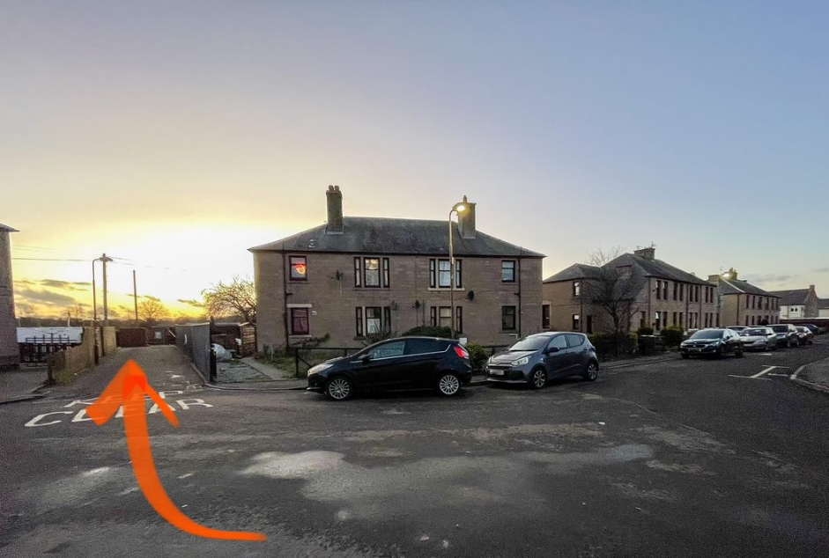

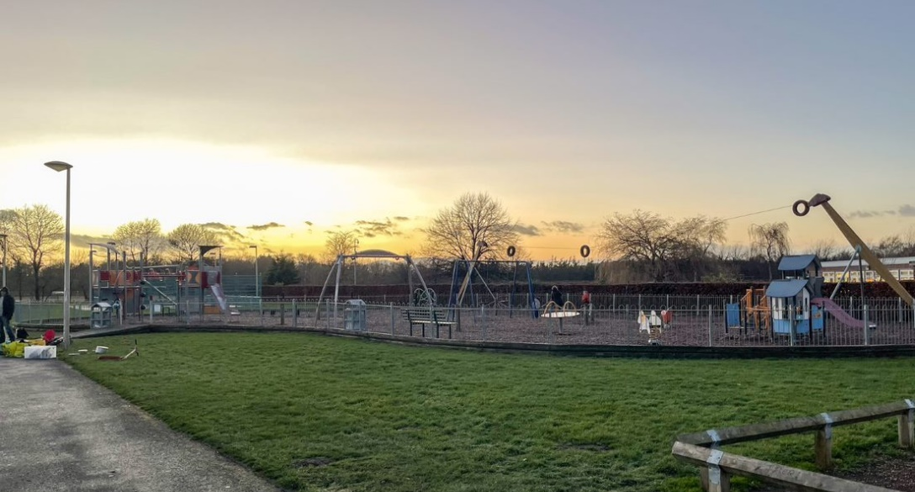

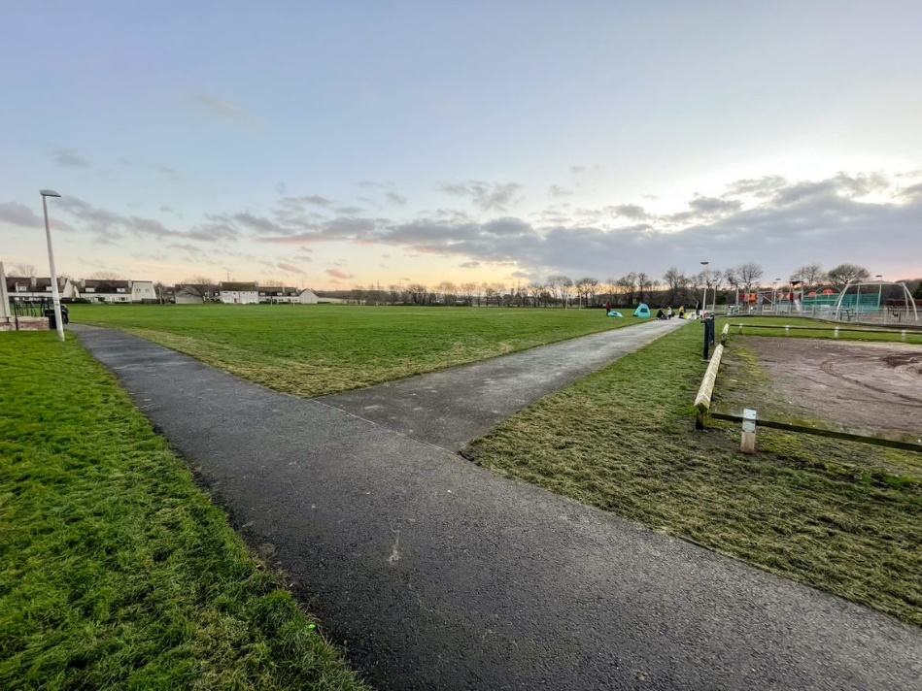

We would love for you to…
Come along to play with your children and family. Give us feedback - what works? what doesn’t? Give us ideas to make things work better Help us shape the next stages of the project!
If you would like further information, or to let us know you plan to come along, contact hello@can-do.scot. We look forward to meeting you at our new sessions, Team PlayCan!

