Location sheet for Spark Park /PlayCan inclusive outdoor play session:
Tranent, 30th Dec 2022, 12noon -3pm
Where | The green space between Tranent Library and Lindores Drive, EH33 1AJ.  And the Fraser Centre Cafe, 3A Winton Place, Tranent, EH33 1AF  The Fraser Centre - The Fraser Centre  Everyone attending the event can get a voucher for a free drink from The Fraser Centre. (Thanks to Fa’side Support from the Start!)
Parking | There is a car park beside the green space, another beside the library and a smaller one immediately outside the Fraser Centre. 90 minutes maximum may apply. Long-stay parking is available further along Lindores Drive at Foresters Park. There is also on-street parking with disabled parking bays nearby
Public transport | Lothian Buses, East Coast Buses and Prentice Coaches run buses to Tranent. We recommend TravelineScotland for up-to-date information.  It is only a few minutes’ walk from the bus stops to the green space and The Fraser Centre.
Toilets | There are accessible toilets in the Fraser Centre
Wheelchair access | The green space has a wide path running through it.  The Fraser Centre is a modern, accessible building.
Seating and benches | There is no seating in the green space, but our team will have a couple of folding chairs.  There is plenty of seating in the café area of the Fraser Centre.
Things to be aware of | Wrap up warm for the weather. We’ll have active games to keep warm and a tent for shelter. We also have spare jackets and gloves if you need an extra layer! The green space has lovely trees for playing and shelter.  The space is open to members of the public, who may have dogs with them.  One edge of the space opens onto the road at Lindores Drive. Our activities will be based further up the space away from this road.  There is a busy road between the green space and The Fraser Centre. Please be careful when crossing the road.  The Fraser Centre café will be open. It is economically priced and has a nice range of drinks, snacks and meals. The café is open to the public.
PlayCan resources | Team PlayCan will bring a range of resources including ‘loose parts’ play kit, percussion, pots & pans, large tent, shelter, tuff trays, chalk, parachute, sensory resources.  Staff from team ELPA and PlayCan will be there to welcome you, and to support and facilitate play.

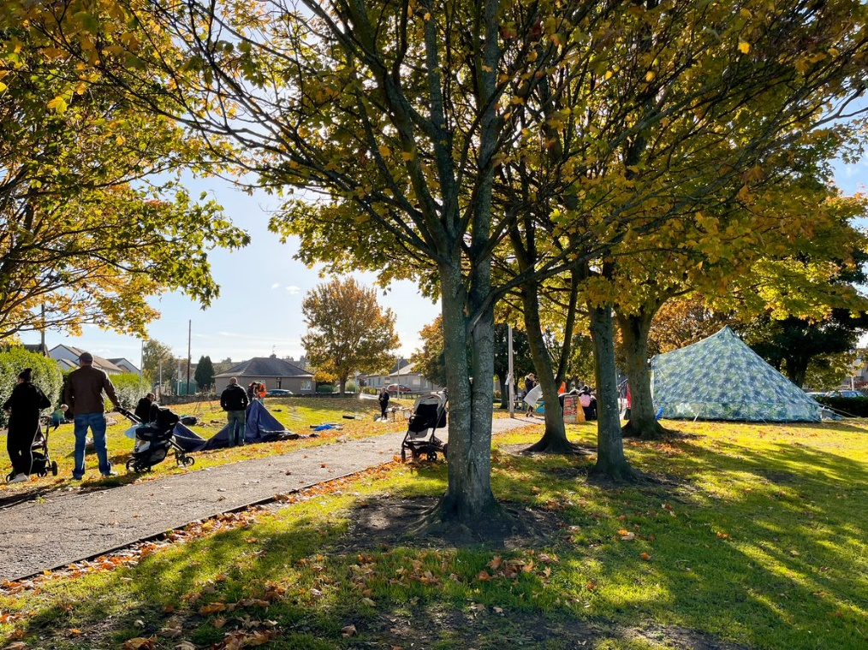
Green space between Tranent Library and Lindores Drives
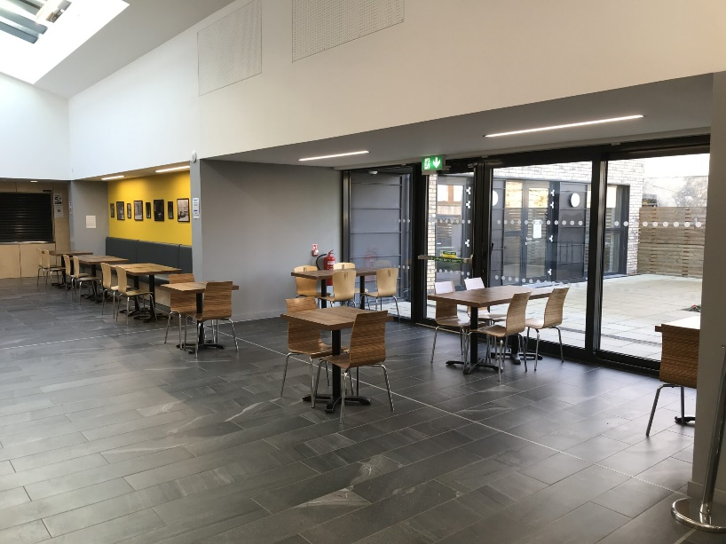Fraser Centre café area
We would love for you to…
Come along to play with your children and family. | Give us ideas to make things work better.
Give us feedback - what works? what doesn’t? | Help us shape the next stages of the project!
If you would like further information, or to let us know you plan to come along, contact hello@can-do.scot. We look forward to meeting you at our new sessions, Team PlayCan!

